**Mini-Project #3: Cross Tabs**

By: Noah Dunn and Scott Harris

Q1:

**SELECT** film_title, **COALESCE**("Lethbridge", 0) **AS** "Lethbridge", **COALESCE**("Woodridge", 0) **AS** "Woodridge"

**FROM** crosstab

('SELECT f.title, ci.city, COUNT(*)::integer

FROM film f, payment p, rental r, inventory i, store s, address a, city ci

WHERE p.RENTAL_ID = r.RENTAL_ID AND

r.INVENTORY_ID = i.INVENTORY_ID AND

f.FILM_ID = i.FILM_ID AND

i.store_id = s.store_id AND

s.address_id = a.address_id AND

a.city_id = ci.city_id

GROUP BY f.title, ci.city

ORDER BY f.title, ci.city',

'SELECT DISTINCT ci.city FROM city ci WHERE ci.city = ''Lethbridge'' OR ci.city = ''Woodridge'' ORDER BY ci.city')

**AS** city_values(film_title text, "Lethbridge" **integer**, "Woodridge" **integer**);

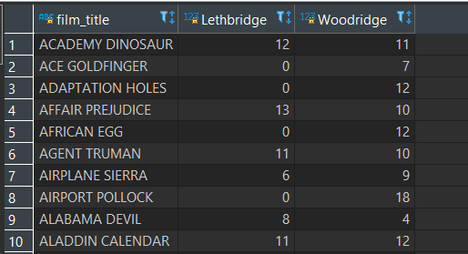

Q2:

**SELECT** custEmail, **COALESCE**("G", 0) **AS** "G", **COALESCE**("PG", 0) **AS** "PG", **COALESCE**("PG-13", 0) **AS** "PG-13", **COALESCE**("R", 0) **AS** "R", **COALESCE**("NC-17", 0) **AS** "NC-17"

**from** crosstab (

'select c.email, f.rating, sum(p.amount)::numeric

from pagila.customer c, pagila.film f, pagila.payment p, pagila.rental r, pagila.inventory i

where c.customer_id = p.customer_id and

p.rental_id = r.rental_id and

r.inventory_id = i.inventory_id and

i.film_id = f.film_id and

c.customer_id > 597

group by c.customer_id, f.rating

order by 1, 2',

'select distinct rating from pagila.film order by 1')

**as** customer_rating_payments(custEmail text, "G" **numeric**,"PG" **numeric**, "PG-13" **numeric**, "R" **numeric**, "NC-17" **numeric**);

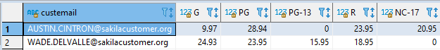

Q3:

**SELECT** filmTitle, **COALESCE**("Jan", 0) **AS** "Jan", **COALESCE**("Feb", 0) **AS** "Feb", **COALESCE**("Mar", 0) **AS** "Mar", **COALESCE**("Apr", 0) **AS** "Apr", **COALESCE**("May", 0) **AS** "May", **COALESCE**("Jun", 0) **AS** "Jun", **COALESCE**("Jul", 0) **AS** "Jul", **COALESCE**("Aug", 0) **AS** "Aug", **COALESCE**("Sep", 0) **AS** "Sep", **COALESCE**("Oct", 0) **AS** "Oct", **COALESCE**("Nov", 0) **AS** "Nov", **COALESCE**("Dec", 0) **AS** "Dec"

**from** crosstab (

'select f.title, extract(month from p.payment_date), sum(p.amount)::numeric

from pagila.customer c, pagila.film f, pagila.payment p, pagila.rental r, pagila.inventory i

where c.customer_id = p.customer_id and

p.rental_id = r.rental_id and

r.inventory_id = i.inventory_id and

i.film_id = f.film_id and

c.customer_id > 597

group by 1, 2

order by 1, 2',

'values (1), (2), (3), (4), (5), (6), (7), (8), (9), (10), (11), (12)'’

) **as** customer_rating_payments(filmTitle text, "Jan" **numeric**,"Feb" **numeric**, "Mar" **numeric**, "Apr" **numeric**, "May" **numeric**, "Jun" **numeric**, "Jul" **numeric**, "Aug" **NUMERIC**, "Sep" **numeric**, "Oct" **numeric**, "Nov" **numeric**, "Dec" **numeric**);

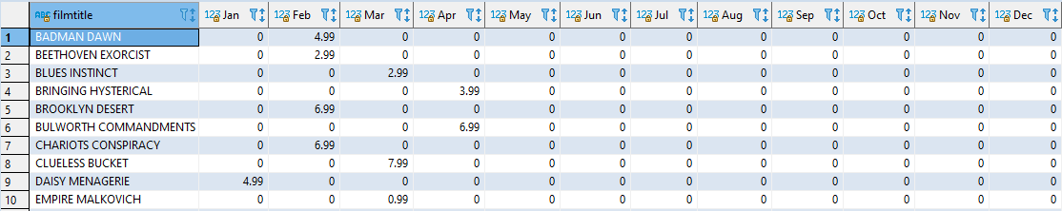

Q4:

**SELECT** actorName,

**COALESCE** ("Action", 0) **AS** "Action", **COALESCE** ("Animation", 0) **AS** "Animation",

**COALESCE** ("Children", 0) **AS** "Children", **COALESCE** ("Classics", 0) **AS** "Classics",

**COALESCE** ("Comedy", 0) **AS** "Comedy", **COALESCE** ("Documentary", 0) **AS** "Documentary",

**COALESCE** ("Drama", 0) **AS** "Drama", **COALESCE** ("Family", 0) **AS** "Family",

**COALESCE** ("Foreign", 0) **AS** "Foreign", **COALESCE** ("Games", 0) **AS** "Games",

**COALESCE** ("Horror", 0) **AS** "Horror", **COALESCE** ("Music", 0) **AS** "Music",

**COALESCE** ("New", 0) **AS** "New", **COALESCE** ("Sci-Fi", 0) **AS** "Sci-Fi",

**COALESCE** ("Sports", 0) **AS** "Sports", **COALESCE** ("Travel", 0) **AS** "Travel"

**FROM** crosstab(

'SELECT concat(sub.fname, '' '', sub.lname)::text as fullname, sub.category::text, sub.filmCount::numeric

FROM (

SELECT a.first_name::text AS fname, a.last_name::text AS lname, c.name::text AS category, count(f.film_id)::numeric AS filmCount

FROM actor a, film_actor fa, film f, film_category fc, category c

WHERE a.actor_id = fa.actor_id AND

fa.film_id = f.film_id AND

f.film_id = fc.film_id AND

c.category_id = fc.category_id

GROUP BY fname, lname, category

ORDER BY lname, fname, category

) AS sub

GROUP BY fullname, sub.category, sub.filmCount, sub.lname, sub.fname

ORDER BY sub.lname, sub.fname, sub.category',

'SELECT DISTINCT name FROM category ORDER BY 1'

) **AS** actor_film_categories (

actorName TEXT,

"Action" **NUMERIC**, "Animation" **NUMERIC**, "Children" **NUMERIC**, "Classics" **NUMERIC**,

"Comedy" **NUMERIC**, "Documentary" **NUMERIC**, "Drama" **NUMERIC**, "Family" **NUMERIC**,

"Foreign" **NUMERIC**, "Games" **NUMERIC**, "Horror" **NUMERIC**, "Music" **NUMERIC**,

"New" **NUMERIC**, "Sci-Fi" **NUMERIC**, "Sports" **NUMERIC**, "Travel" **NUMERIC**);

